IAIS Strategic Plan 2025-2029 stakeholder survey

The IAIS has launched a process to develop its next Strategic Plan which will guide its work over the five-year period from 2025 to 2029. It will replace the current Strategic Plan which concludes at the end of 2024.
Stakeholder engagement is essential to the IAIS’ ability to deliver on its mission. Input from stakeholders will allow the IAIS to have a more comprehensive picture of emerging risks and trends in the sector and to include a range of perspectives in its planning, ensuring that the work we will embark upon in the coming years is most effective and meaningful.
The IAIS is inviting stakeholders to share their views through this survey. Responses to the survey are invited by 18 July 2023.

- Please provide the following information:

- Name:

- Email address:

- Name of country / jurisdiction:

- Name of organisation:

- Which of the following categories best describes your organisation: mandatory
- Academic
- Consumer group
- Insurer or intermediary
- Media
- Trade association
- Consultancy or advisory firm
- Financial sector supervisor
- Other

6.a.If other, please specify ……..

Strategic themes and overarching objectives
At present, there are a number of strategic themes which shape the focus of the IAIS’ work programme. These are both global and cross-sectoral in nature therefore benefitting from international coordination and collaboration.

- Of the below existing priorities of the IAIS, what degree of priority do you consider they warrant in the period 2025-2029?

Topic | Low priority | Low to Moderate priority | Moderate priority | Moderate to High priority | High priority
Climate-related risks | ○ | ○ | ○ | ○ | ○
Conduct and culture | ○ | ○ | ○ | ○ | ○
Digital innovation | ○ | ○ | ○ | ○ | ○
Diversity, equity and inclusion | ○ | ○ | ○ | ○ | ○
Financial inclusion | ○ | ○ | ○ | ○ | ○
Operational resilience and cyber risk | ○ | ○ | ○ | ○ | ○

- For the topics that you rated as a “high priority”, what are the specific aspects that you believe the IAIS’ work should focus on?

- What other key risks and trends affecting insurance markets should the IAIS consider as a priority as part of the next Strategic Plan, with what particular areas of focus?

At present, the IAIS’ work is directed at achieving five High-Level Goals (HLGs) which outline the core functions of the IAIS, and strategies to achieve the IAIS’ objectives. These are outlined below.
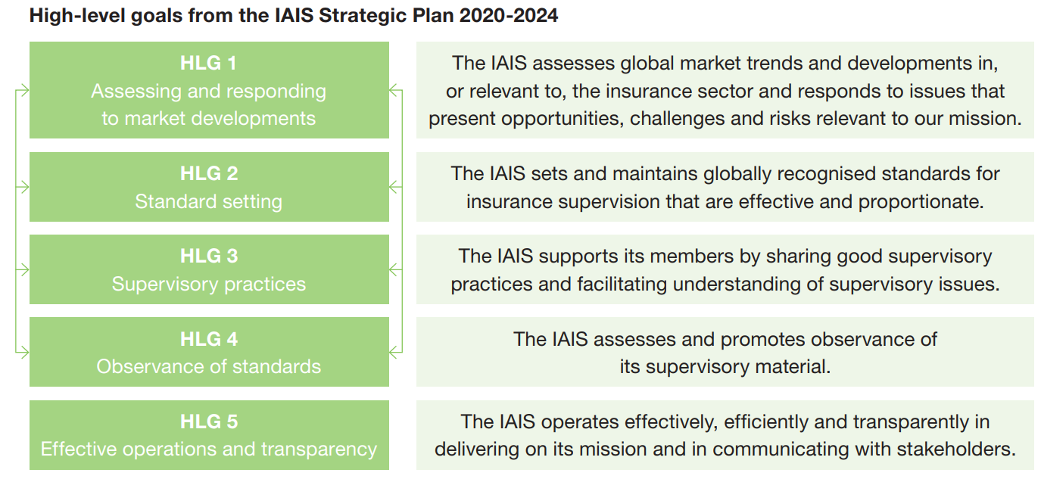

- Which of these HLGs do you think should be the focus of the IAIS’ work in the period 2025-2029? [Please rank in order]
  - Assessing and responding to key risk and trends in the global insurance sector (HLG 1)
  - Setting and maintaining globally recognised standards for insurance supervision (HLG 2)
  - Sharing good supervisory practices (HLG 3)
  - Observance of standards through implementation assessment and support (HLG 4)
  - Effective, efficient and transparent operations (HLG 5)
  - Other

10a. If ‘Other’ please specify

- Regarding HLG 1 (work to assess and respond to key risk and trends in the global insurance sector), what do you consider most important for the IAIS to prioritise in the 2025-2029 period? [ranking, at least one option]
  - Enhancing and enriching data collection to support IAIS assessment
  - Developing opportunities for dialogue with stakeholders on risk and trend assessment
  - Increasing the frequency of IAIS assessment and reporting
  - Developing more regional approaches to risk assessment and responses
  - Other

11a. If ‘other’ please specify

- What standard setting and work on supervisory practises should the IAIS be focused on delivering towards the end of the decade? [ranking, at least one option]
  - Review and update IAIS standards (Insurance Core Principles (ICPs) and/or ComFrame) either on a regular schedule or in a more targeted way to reflect emerging trends and risks, or outcomes of implementation assessment
  - Further enhancements to the ICS following an initial implementation period
  - Developing a global capital standard for insurers that are not internationally active insurance groups (IAIGs)
  - Development of supporting material in relation to the existing standards (ie Issues Papers / Application Papers) to enable effective supervision of new/emerging risks and trends
  - Other

12a. If ‘other’ please specify

- What implementation assessment issues should the IAIS focus on in the 2025-2029 period? [ranking, at least one option]

  - Expanded implementation assessment activities for members with the objective of allowing a broad range of jurisdictions to benchmark their observance of IAIS standards
  - Targeted implementation assessment activities for members with the objective of furthering the consistent and comprehensive implementation of recently agreed key reforms in major insurance markets (eg Holistic Framework supervisory measures, ComFrame, ICS)
  - Progress monitoring work, focusing on self-reporting of jurisdictions’ progress in implementing IAIS standards

13a. If ‘other’ please specify

- What capacity building issues should the IAIS focus on in the 2025-2029 period? [ranking, at least one option]
  - Enhanced supervisory capacity building initiatives to address gaps and challenges in the implementation of IAIS standards and good supervisory practices
  - Enhanced supervisory capacity building activities to support the transition to risk-based solvency regimes and risk-based supervision
  - Enhanced supervisory capacity building activities to support jurisdictions’ implementation on macroprudential supervisory measures
  - Other

14a. If ‘other’ please specify

IAIS Activities
- What type of outputs and/or activities from the IAIS are most beneficial for you? [ranking, at least one option]

  - Supervisory materials (global standards for insurance supervision incl. ICPs and ComFrame)
  - Supporting materials (written public materials on supervisory practices and key trends, incl. Issues and Application Papers and other Reports)
  - Annual publications (GIMAR, Year in Review)
  - IAIS Newsletter
  - Global events (Global Seminar, Annual Conference, webinars)
  - Regional activities
  - Capacity building
  - Implementation assessment reports
  - IAIS website
  - IAIS email alerts
  - IAIS LinkedIn account
  - Other

15a. If ‘Other’ please specify

- Can you briefly explain how you currently use IAIS work, in your organisation?

- Are there IAIS activities where you think change, or improvement, is needed?

Other comments

- Do you have any other comments or suggestions with respect to the IAIS’ Strategic Plan 2025-2029?

